Erick Rivera November 12, 2019
English Composition Mr. Duran

Capital Punishment Moral Code Political Cartoon

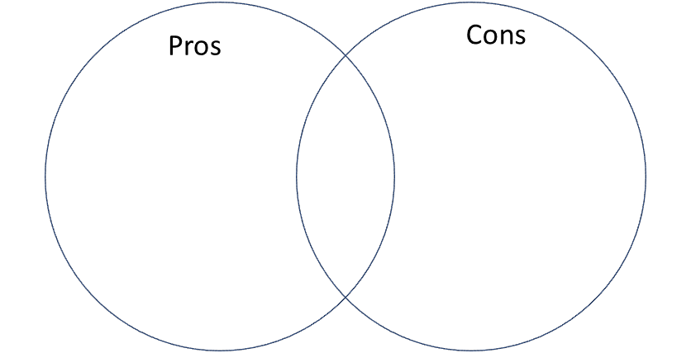
Both believe in justice, believe they’re right, and have extreme views on the killing of criminals.
- “This world is rotten and those who are making it rot deserve to die. Someone must do it, so why not me?”
- Uses supernatural notebook, the Death Note, to eliminate people he deems morally unworthy of life to make a perfect utopian society without crime.
- Seeks justice and retribution of others; “Look around you, and all you will see are people the world will be better off without.”
- “I believe in the absolute sacredness of human life; I may not really believe in anything else.”
- Bill Finger said his traumatizing origin story showed him, “the sudden murder taught Bruce to cherish and respect life as much as it taught him to hate criminals.”
- High moral code has him take no pleasure in death, rather bring dangerous criminals like the Joker behind bars than kill him.

Capital Punishment Fact Sheet
The death penalty or capital punishment is a practice used and by multiple governments across the globe where a person is killed by the state as a punishment for their crimes and it's often used as a deterrent to stop extreme criminals. Before their execution, these criminals are sentenced to death after the court process of serious capital felonies such as mass murder, multiple cases of rape, child rape, terrorism, attempts to overthrow the government, genocide and many more depending on the country. There also comes a lot of interesting statistics and correlations made from capital punishment.

- In many states such as Louisiana, California, and North Carolina saw that defendants whose victims were white had odds of a death sentence at 97% higher, three and four times more likely to be sentenced to death compared to black and Latino victims, and 3.5 times higher according to many studies respectively.
- In 96% states with reviews of race and death penalty there is a huge pattern of race of victim and defendant discrimination.
- In the “Deterrence and the Death Penalty,” by the National Research Council, claims that capital punishment as a deterrent is fundamentally flawed
- The 2018 FBI Uniform Crime Report shows that even though the South has over 80% of the United States executions, they have the highest murder rate at 6 per 100,000. North East has only 1% of all executions with low murder rate of 3.4 per 100,000.
- In a 2009 survey by the presidents of the United States’ top criminological societies found that 88% of them found the death penalty to be a weak deterrent to murder

- In a 2010 poll by Lake Research Partners found a majority of voters at 61% found that they would chose any other punishment than capital punishment with life without parole plus restitution being the highest.
- In a 2009 poll by the Death Penalty Information Center among police chiefs see the death penalty as the least effective way to reduce crime.
Cited Sources
Kandola, Sunpreet Singh, and Vincent Egan. “Individual Differences Underlying Attitudes to the Death Penalty.” Personality and Individual Differences, vol. 66, 2014, pp. 48–53., doi:10.1016/j.paid.2014.03.005.
“Fact Sheet.” Death Penalty Information Center, 2 Oct. 2019, https://deathpenaltyinfo.org/facts-and-research/fact-sheet.
“Student Research Center.” Death Penalty Information Center, https://deathpenaltyinfo.org/facts-and-research/student-research-center.
Kistler, Alan. “Why Batman Stopped Killing People in 1940.” Polygon, Vox Media, 2 Apr. 2019, https://www.polygon.com/2019/4/2/18292128/batman-no-killing-rule-zack-snyder.
Roberts, Shannon. “‘Death Note’ Is An Anime For The Morally Ambiguous.” The Odyssey Online, The Odyssey Online, 18 Dec. 2017, https://www.theodysseyonline.com/death-note-anime-morally-ambiguous.
Kronenwetter, Michael. Capital Punishment: A Reference Handbook. 2nd ed., vol. 1, ABC-CLIO, 2002.
“DPIC 2010 Public Opinion Poll.” Death Penalty Information Center, 4 Nov. 2019, https://deathpenaltyinfo.org/stories/dpic-2010-public-opinion-poll.
Nagin, Daniel, and John Pepper. Deterrence and the Death Penalty. National Academies Press, 2012.

Rationale
The First Genre: A Political Satire Cartoon
Rhetorical Situation: The debate on capital punishment has strong arguments from people on both sides being strongly against it and other in full support of the practice of executing criminals.
Genre: I used a political cartoon with popular media characters such as Batman and Light Yagami from Death Note to deliver my message in a entertaining way with some characters familiar to audiences.
Audience: My political cartoon is meant to appeal to a younger audience who have a familiarity and could have a laugh with the characters used in my genre such as college students or high schoolers. Another audience those who are questioning the morality of the death penalty and would like to see the radical opinion from both sides.
Purpose: The purpose of this genre is to entertain my audience with both characters having both very strong sided radical opinions on executing criminals with Batman being against the killing of anyone and Light being all for killing criminals. The genre would also make my audience start questioning their own morality and who they would relate to more if they had to chose a stance on the capital punishment debate.
Medium: Online Venn diagram
Stance: The stance is very neutral with it being satirical and showing both sides of the extreme in this debate on the death penalty.
The Second Genre: Fact and Statistics Sheet
The rhetorical situation: This shows the current updated statistics and information gathered by many sources online that show the real and true gravity and weightiness of the death penalty in the United States.
Genre: A fact and statistic sheet and I found this genre effective because it’s simple and delivers the information in a easy way to be followed my audience.
Audience: My audience would be the general public who have strong opinions or are interested in learning more about capital punishment without being influenced by a biased viewpoint and just want to see the neutral true facts.
Purpose: The purpose of my genre is to educate and inform my audience with unbiased facts and statistics so that they can use their own thoughts and opinions to form their own stances on the death penalty debate and possibly go out and research more on this controversial topic.
Medium: Online statistic sheet
Stance: The stance is neutral with some slight bias being against the death penalty with some factual responses to surveys and questions such as the National Research Council response to the death penalty as a deterrent to crime to be “fundamentally flawed.”

